**Backup and Redeployment  
  
Backup**  
1) We can always backup the Nodered flows and Grafana Dashboards in the JSON format.  
  
I have already backed it up and these can be found in the below path of this repository.  
 **Node Red Jsons - Digital_EcoSystem_Dev/NodeRed**

**Grafana Jsons - Digital_EcoSystem_Dev/Grafana**

Whenever we want to redeploy this in any other system then we can just import this json files in Nodered and Grafana as shown below.  
  
Assuming the docker images of Nodered, Grafana, Influxdb and MQTT are already involved. Let go ahead with the Influx DB part first.  
If Docker images are not installed then we can use the below links to Install  
 **1) Node red - https://nodered.org/docs/getting-started/docker  
  
2) MQTT - https://hub.docker.com/_/eclipse-mosquitto  
  
3) Grafana - https://grafana.com/docs/grafana/latest/installation/docker/  
  
4) InfluxDB - https://hub.docker.com/_/influxdb**

**Influx DB part  
  
Step 1 -**We just need to open the Influx DB through CLI

**Step2** - Type influxdb  
**Step 3-** Create Database databasename  
  
In our case we named the database as **Sensors_Realdata**

**Nodered part  
  
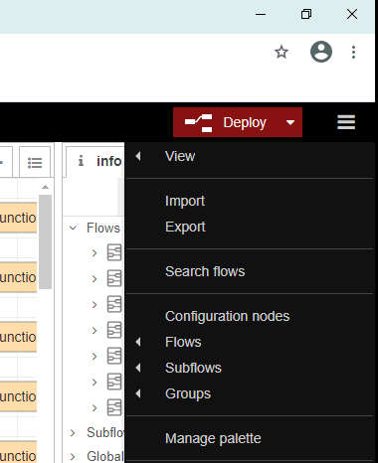  
And then select the JSON that we downloaded.**

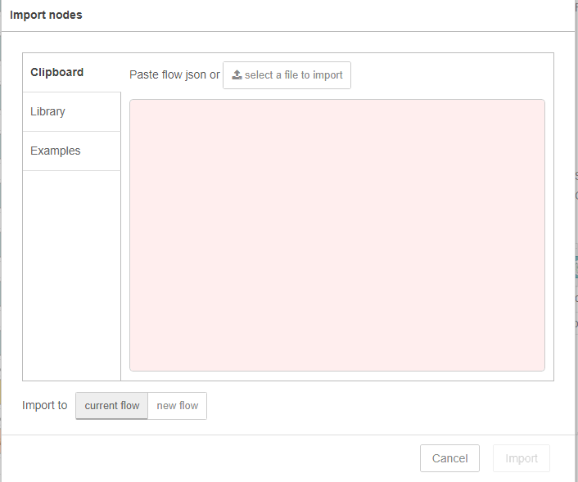

We can either select JSON of all the flows together or we can select them individually too. Folder Structure is as follows   
 **EntrieFlow.json -** contains al the Json **Single Json flows folder -** contains all JSONs individually

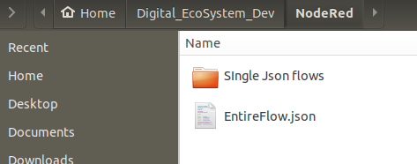

**Grafana**

**Before adding the Json we need to add the data source in Grafana using the below screenshots  
  
Step 1 - Click on the Data Source option from the side bar**

**Step 2 - Choose Influx DB as data source  
Step 3- Enter the HTTP URL as** [**http://localhost:8086**](http://localhost:8086) **- 8086 is the port where influxdb is installed. If we have installed it in someohter port, then we need to use that particular port.  
Step4- Change the access to Browser  
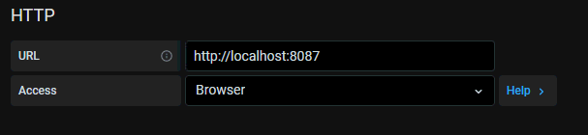  
Step5 - Save and Test  
Step 6- The above settings are saved only when we get the below message**

**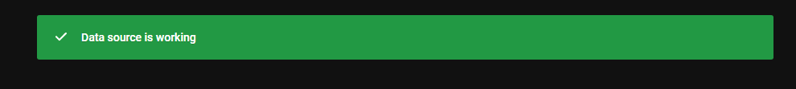  
  
Step 7- Click on create dashboard  
Step 8 - click on Import   
Step9 - Copy and paste the JSON file.  
  
  
  
Docker Compose   
  
To start - docker-compose up  
To stop - docker-compose down  
  
Steps that I followed to get the existing data  
  
1) Copied the docker volume from the existing containers to our local.  
2) Then created Docker volumes for new images  
3)Copied the historical volumes from local to new docker volumes  
4) Created Docker compose yml file  
5) Running the docker compose**

**Docker compose yml file code**

**version: "3"**

**volumes:**

**node_red_data:**

**grafana_data:**

**influxdb_data:**

**services:**

**nodered:**

**image: "nodered/node-red"**

**ports:**

**- "1881:1880"**

**volumes:**

**- node_red_data:/Node_red**

**grafana:**

**image: "grafana/grafana"**

**ports:**

**- "3001:3000"**

**volumes:**

**- grafana_data:/data**

**influxdb:**

**image: "influxdb:1.8"**

**ports:**

**- "8087:8086"**

**volumes:**

**- influxdb_data:/Influxdb**